# Exercise: Using time intelligence to compare to previous year

## **Introduction**

You should now understand the fundamentals of DAX and time intelligence at this lesson stage.

This exercise asks you to apply your knowledge of these concepts by creating measures using DAX expressions in Power BI.

By completing this exercise, you will demonstrate your ability to:

* Create measures to compare Adventure Works' year-over-year sales growth.
* Form measures for an appropriate data type.
* Create a matrix to view the results of the time intelligence comparison.

## **Scenario**

Adventure Works needs to analyze the performance of its sales team and growth to plan for the next financial year. The company needs your help to generate the insights required to build this business plan.

Begin by helping Adventure Worksto evaluate its sales from the previous year to compare the sales team's performance for the current year. Then calculate Adventure Works' year-over-year change in sales to analyze the company’s growth and monthly and annual trends in sales volume.

Adventure Works provides a Power BI project file called *AdventureWorks.pbix* that contains the required data model. You must load this dataset into Power BI, evaluate the data quality, and configure the model to ensure that Adventure Works can use it to make informed decisions.

## **Instructions**

Create a new Power BI project called *Exercise - Using Time Intelligence to compare to the previous year*. Follow the steps below to complete the exercise.

### **Step 1: Download the Adventure Works Power BI project.**

1. Download and save the Power BI project Adventure Works.pbix. The Power BI data model contains four tables of data: Sales, Products, Region, and Salesperson.

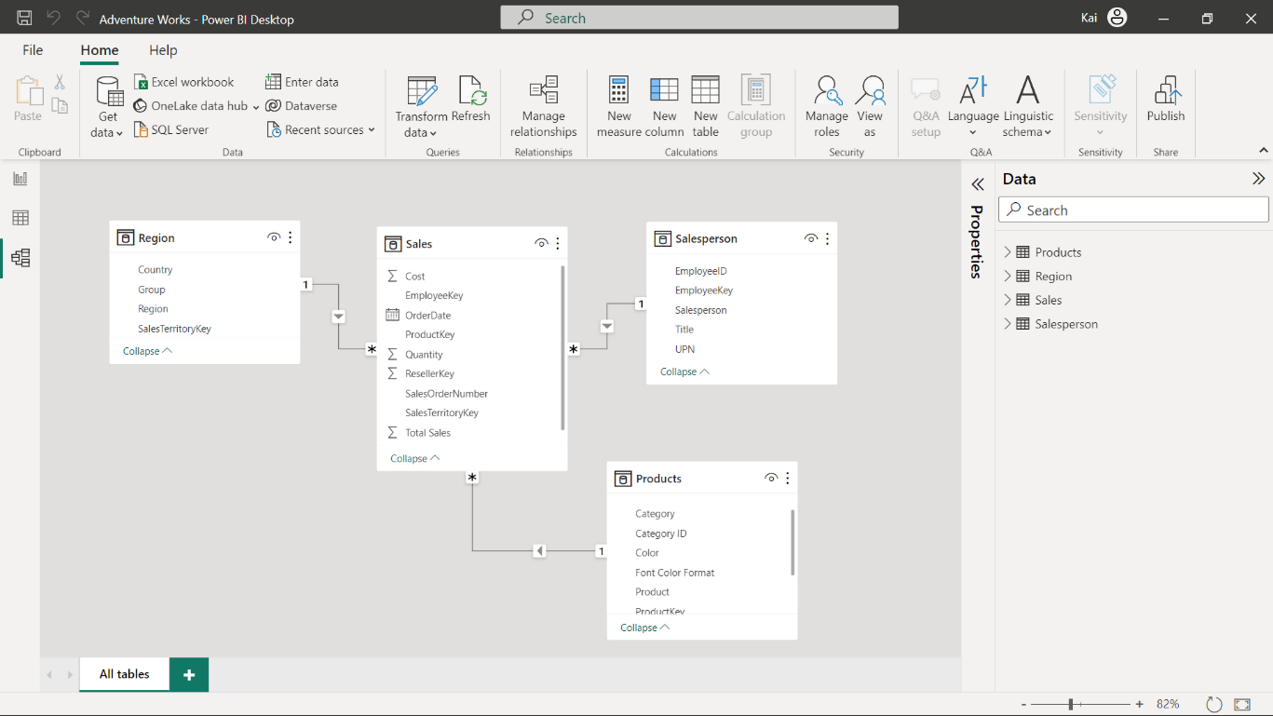

1. Load the data from the Excel sheet into Power BI. Ensure you load all tables in the workbook.
2. Open a preview of the table in the Preview pane.

Tip: You can import data using the Get Data drop-down menu.

### **Step 2: Create the Revenue measure.**

1. Once the data is loaded into the data model, create a new measure called Revenue. You need to use the Total Sales column from the Sales table and the Quantity column from the Sales table. You’ll use this measure to complete the remaining steps in this exercise.
2. Format the measure as currency data type within two decimal places.

Tip: You can create this measure by using the DAX SUMX function.

### **Step 3: Create the previous year’s and year-over-year revenue changes using DAX query.**

1. Create an additional measure in the sales table for the previous year’s sales called RevenuePY by writing a DAX expression using a time intelligence function.
2. Format the measure as currency data type within two decimal places.

Tip: You can create this measure using the SAMEPERIODLASTYEAR DAX function inside the CALCULATE in the formula bar of the Power BI desktop interface. You can also use variables to write your DAX expression.

1. Create a measure called Revenue YoY to evaluate the year-over-year change in sales for Adventure Works.
2. Format the measure as a percentage data type within two decimal places.

Tip: You can modify the previous year's measure using the DIVIDE function in DAX.

### **Step 4: Update the matrix in Power BI to view the results of the measures.**

1. Update the matrix in Power BI desktop report view by bringing revenue, previous year revenue and revenue year-over year change to the matrix against months and year.

Tip: You can access a premade matrix by navigating to Power BI’s Report view.

1. Note the values in all columns of the matrix/table.

### **Step 5: Save the Power BI project.**

* Save your Power BI project to your local computer.

Tip: Make sure you select an appropriate project name and folder path.

## **Conclusion**

With these steps, you have successfully created measures to help Adventure Works analyze its data based on its analytical and business requirements and proven your capabilities with time intelligence functions.

Remember that when using DAX formulas, always ensure they are correctly formatted and that the column names match the actual column names in your data.